

***La Habra High School***

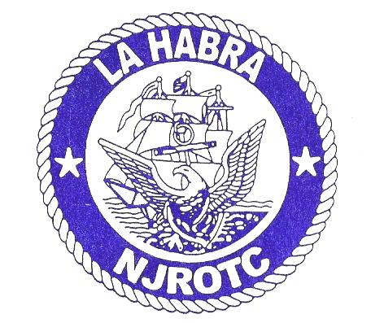

**Navy JROTC**

**801 West Highlander Ave**

**La Habra, CA 90631**

Future cadets and their parents,

We are excited to welcome you to the La Habra High School NJROTC unit! We are an award winning unit with a tradition of excellence, and we will provide you with the opportunity to learn citizenship and leadership skills that will last a lifetime. We are excited to see what you will bring to the unit during your time here as a cadet.

NJROTC does not require a military commitment. However, it will provide you with the skills and structure you need to excel in high school and beyond.

In order to help ease the transition into our unit, you are invited to our new cadet orientation on Tuesday, 8 August from 0900 (9:00am) to 1200 (noon). Cadets will explore our spaces and learn what it means to be a cadet. They will be given the chance to meet and interact with the unit’s cadet leaders for the 2023-24 school year, who will teach them the basics of NJROTC. We will answer any questions you may have about life as a cadet or a high school student. Cadets will also receive a uniform from the supply department.

After our scheduled activities, we will host a unit picnic from 1200 (noon) to 1400 (2:00pm). Parents and family are welcome to join us!

Attendance is not mandatory but highly encouraged. There is no charge for the picnic for new cadets and their families. Our instructors and I are excited to see you there!

Details about NJROTC can be found on the LHHS webpage by navigating to Departments/Academies and then selecting NJROTC (<https://www.fjuhsd.org/Page/1351>) Please let us know you will be coming to orientation by emailing our senior naval science instructor at [rballister@fjuhsd.org](mailto:rballister@fjuhsd.org). Also attached is some reference material for you to become familiar with that details key elements of NJROTC, such as uniform wear and rank structure.

Very respectfully,

M. Tierney

c/LCDR

Cadet Commanding Officer